ME139L Experimental Heat Transfer
Background and Guidelines for Lab #2

Thermal Conductivity and Heat Capacity Measurements
Objectives
- Understand thermal conductivity measurement methods and errors caused by surface heat loss and other sources.
- Learn non-contact optical based temperature measurement techniques including infrared imaging and reflectivity measurements
- Utilize transient temperature measurements to obtain heat capacity, which is an important parameter for thermal energy storage and other applications.

Background
Measurements of thermal transport properties of functional materials and devices are important tasks in many industries and research laboratories. A number of methods have been developed for measurements of thermal conductivity, thermal diffusivity, specific heat capacity, and thermal contact resistances. For direct measurements of the thermal conductivity of a sample, the steady-state temperature response of the sample is measured when heat flows in the sample. In this lab, we will learn two different steady-state thermal conductivity measurement methods. In one method, the sample thermal conductivity is determined from one-dimensional (1D) heat conduction analysis of the measured temperature distribution along a long rod sample sandwiched between a heater and a heat sink. In the other method, the sample thermal conductivity is extracted from two-dimensional (2D) heat conduction analysis of the measured surface temperature inside a heating laser spot focused on a thin film metal coating of a thick and large plate sample.

The sample surface temperature needs to be measured accurately in both of these two thermal conductivity measurement methods and other applications. When a thermocouple, resistance temperature device (RTD), or thermistor is used to measure the surface temperature of a sample, heat conduction between the sample and the electro-thermal transducer alters the sample temperature. The presence of the contact thermal resistance between the sample surface and the temperature sensor can further cause a deviation of the sensor temperature from the sample surface temperature. In addition, it takes time for the sensor temperature to reach a steady-state value.

To avoid these errors in contact measurements of the surface temperature, we employ two optical-based non-contact temperature measurement techniques for steady-state thermal conductivity measurements. In one non-contact method, infrared (IR) radiation from a surface or gas can be used to measure the temperature because the radiation emission depends on the sample temperature. For the other method, the reflected intensity of a laser beam focused on a metal film can be measured to determine the temperature of the metal film because the reflectivity of a metal varies with its temperature approximately linearly.

While steady-state temperature measurements can be used to obtain the thermal conductivity, measurements of the transient temperature response of a heated sample are required to determine the specific heat capacity and thermal diffusivity. In this lab, we will use an electro-calorimeter to measure the transient temperature response of a heated liquid sample to obtain the heat capacity. The electro-calorimeter shares a similar principle but has more losses than commercial differential scanning calorimetry (DSC) equipment widely used in industry and research settings for heat capacity measurements.

Lab Work (team)
Assemble in the teams that you were placed in. Work through the lab procedures given in the attachments and answer the questions as you go along. Individually record your notes and observations on the attached sheets.

Report (team)
Each team will hand in one memo-style lab report. All calculations, results, questions, etc., that are part of your lab notes should be recorded, summarized and discussed in the team report. Record answers, notes, and observations on a clean sheet of paper or in a Lab notebook. General specifications for the lab report are given in the report template that are posted on Canvas.

Experiments

1. Steady state measurements of thermal conductivity, thermal contact resistance, and surface heat loss of rod samples

Equipment
- Composite rods consisting of two segments made of different materials and joined together with epoxy. Each segment is 0.5 inch in diameter and 6 inch long.
- A 25W electrical heater attached to the top of each composite rod
- An aluminum block heat sink attached to the bottom of each composite rod
- Three power supplies (<30V, <3A)
- FLIR infrared camera
- Laptop with FLIR Tools software
Heater
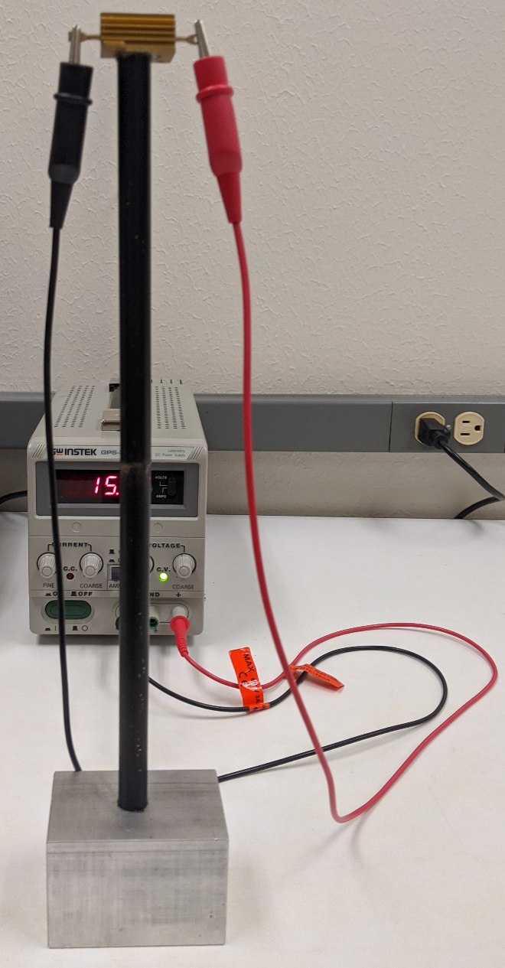
T₄
T₃
T₂
Al heat sink
Joint
T₁

Procedure

**WARNING**: DO NOT TOUCH THE HEATER OR THE COPPER LEADS ON THE HEATER

1. Allow 15-25 minutes for the composite rods to reach steady state. Once equilibrium is reached, use the spot measurement capability (cross-hair) of the IR camera to measure the temperatures T₁, T₂, T₃, and T₄ at the two ends of each of the two segments of the composite rod, as shown in the photo.

Composite Rod | Left | Middle | Right
T₁ (IR)
T₂ (IR)
T₃ (IR)
T₄ (IR)

- Finally, save an infrared image of the rods by pressing “save” on the camera. Line up the camera so that the rods are as vertical as possible in the image. This will be used later to export the temperature distribution along the length of the rods to an Excel spread-sheet.

- Export Experimental Data

Infrared thermography, while of somewhat limited accuracy in terms of absolute temperature measurement at a point, provides the enormous advantage of giving a complete instantaneous temperature picture of a surface in real time. Image analysis software permits us to translate the data collected by the camera into quantitative terms. In this lab, you will use the software provided by the camera manufacturer to analyze the temperature distributions for the fins you imaged. Note, this software is only available in the lab so you must finish this part in lab.

- Connect the USB cord into the camera and download the images you acquired of the constant temperature base rods onto one of the lab computers. Once you have downloaded the images, delete them from the card and safely eject the camera from the computer. Email these files to yourself or save them on a memory stick.
- The images can be opened using the thermal imaging program FLIR Tools. Click “Add” and select the folder that your image is located at. The selected folder is added on the left side of the window. Double-click your image to analyze and the image will show up on the window.
- Select “line measurement” on the left side. Click a short distance above the tip of the first fin. With the mouse button held down, draw a line ending slightly below the base of the fin. Repeat this for each of the other two 3/8” diameter fins.
- Right click and select “Export to CSV”. Scroll down to select “Measurements” and click “Export”. Save this CSV file to your storage device, and this file contains all of the temperature data.
- The CSV file can be opened in Excel, and three temperature profiles will be recorded in a different row. Develop a plot of temperature versus distance for each of the rods. The Excel file will be used for data reduction and analysis. Make sure to email this file to yourself or save it on a memory stick.

2. Steady state thermoreflectance measurements of thermal conductivity of thick plates

Equipment

As shown in the schematic above and explained in the lecture 3 slides, the steady-state thermoreflectance setup uses a 532 nm green pump laser (1) as the heat source. A polarizer (2) is used to adjust the electric field polarization direction of the green laser beam. A neutral density (ND) filter (3) can be moved laterally by a motorized stage to tune the green laser intensity. Three mirrors (4, 5, and 6) reflect the green laser to a mechanical chopper (7). The rotating chopper blades periodically block the green laser from reaching a beam splitter (BS, 8). which reflects part of the beam onto another neutral density (ND) filter (9). The intensity of the reflected and attenuated green laser beam is modulated by the chopper and measured by a photodiode (PD, 10), which sends a voltage signal (P) to a Omega Supermeter (5). The beam splitter (BS, 8) transmits the rest of the green laser beam toward a dichroic mirror (DM, ).
4
A 640 nm red probe laser (1) is used to measure the sample reflectivity. A mirror (2) reflects the red beam to another neutral density (ND) filter wheel (3) to tune the red beam intensity. Two mirrors (4 and 5) reflect the red beam to a half wave plate (HWP, 6), which is adjusted to rotate the electric field polarization direction of the red beam by up to 180º. Upon transmission and reflection by the downstream polarized beam splitter (PBS, 7), the red beam splits into two beams with their electric field polarizations orthogonal to each other and their intensity ratio tunable by adjusting the half wave plate (HWP, 6). The transmitted red beam is reflected by a mirror (8) through a focus lens (9), before this reference red beam is reflected by another mirror (10) onto one of the input ports of a balanced photodetector (BPD, 11).
The other red beam reflected by the polarized beam splitter (PBS, 7) meets the green beam at the long-pass dichroic mirror (DM, ), which transmits the long-wavelength red beam and reflects the short-wavelength green beam through a quarter wave plate (QWP, ). An objective lens () is used to focus both beams onto a thin metal film coating of a thick plate sample (). The thin metal coating on the sample () reflects the two beams back through the objective lens (), the quarter wave plate (QWP, ), and the long-pass dichroic mirror (DM, ), which again reflects most of the green beam and transmits the red beam. The red beam passes through the quarter wave plate (QWP, ) for the second time to have its electric field polarization rotated for 90º between its first and second incidences on the polarized beam splitter (PBS, 7), which now transmits the red probe beam at its second incidence. When a downstream flip mirror () is flipped up, the red beam is reflected to a camera () to view its image on the sample surface during the optical alignment process. When the flip mirror () is flipped down, the red beam goes toward a focus lens (), a mirror (), a filter () that blocks the residual green beam, and finally the second input port of the balanced photodetector (BPD, 11). The balanced photodetector (BPD, 11) provides a voltage output signal (V) that is proportional to the reflected red probe beam intensity and can be measured by a Omega Supermeter (4).
4
3
2
1
1
2
3
4
3
5
6
5
7
8
9
When the green pump laser is blocked by the chopper (7), the half wave plate (HWP, 6) is adjusted to minimize the intensity difference between the reflected red probe beam and the reference red beam at the two input ports of the balanced photodetector (BPD, 11). When the green heating laser passes through the chopper (7) and raises the temperature of the metal coating of the sample () and changes its reflectivity, the reflected probe beam intensity deviates from the reference red beam intensity. The balanced photodetector (BPD, 11) converts this intensity difference into another voltage (ΔV) signal output, which is measured by a lock-in amplifier (LIA, 3) tuned to the chopper frequency. The relative change in voltage (ΔV/ V) output is proportional to the sample surface temperature rise (ΔT) caused by the green heating laser. A two-dimensional heat conduction analysis can be used to extract the thermal conductivity from the measured voltage (ΔV) signal, as discussed in lecture 3 slides.
1

Procedure

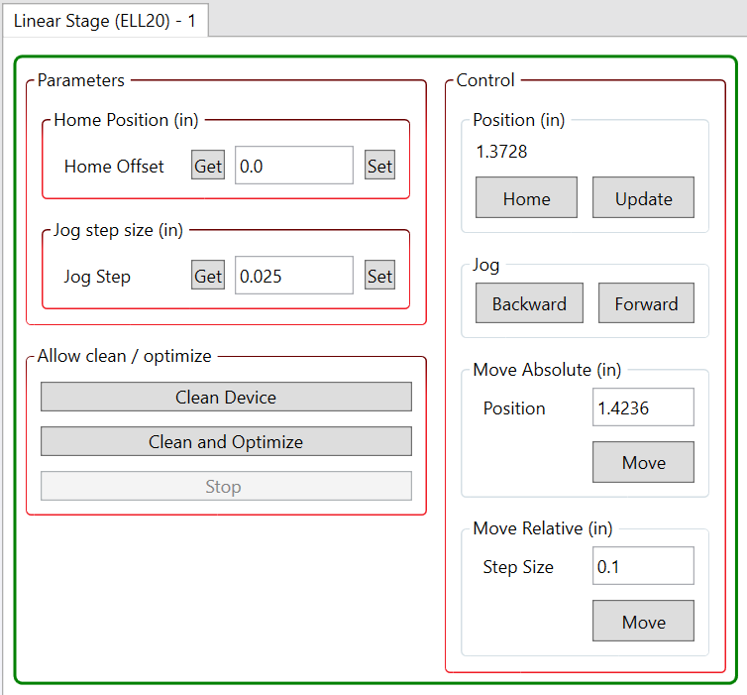
​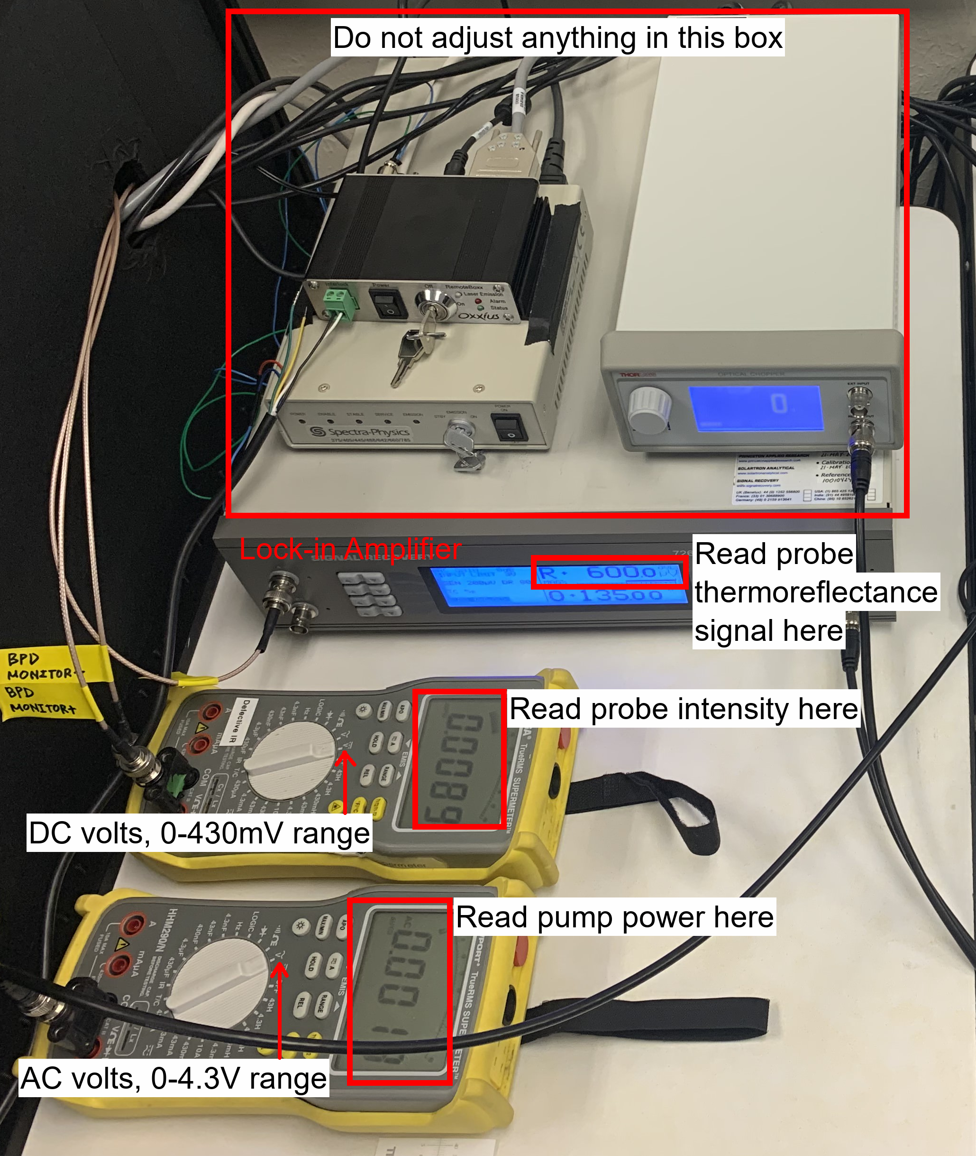​

For the sample measured by your group, use the following procedure to record the measurement data in the table below

- In the pump column, record the Omega Supermeter (5) reading (P) of the photodiode (PD, 10) response of the green pump beam. This signal should an AC voltage in the unit of V due to the modulation of the green pump beam by the chopper.
- In the probe intensity column, record the Supermeter (4) reading (V) of the probe intensity signal from the balanced photodetector. The signal should be DC voltage.
- In the probe thermoreflectance signal column, record the lock-in amplifier (as indicated in the figure) reading of the signal (ΔV) from the balanced photodetector. Take note of the displayed unit; it may be mV or µV. Make sure to convert the value to µV when you write it in the table.
- Make sure that the jog step size is set to 0.025in on the lab computer control program for the motorized stage . Under “Jog” in the ELLO software, click the “Backward” button. The motor will move the neutral density filter (3) to vary the green pump beam density. The voltage signal (P) reported by the Omega Supermeter (5) should change.
- Repeat steps 1, 2, 3, and 4 to fill the rows of the table.
- Your TA will provide their measurement results of a reference sample for analyzing your data based on lecture 3 slides.

Pump power (P) [V_{AC}] | Probe intensity (V)  [V_{DC}] | Probe thermoreflectance signal (ΔV)  [µV]

3. Transient Measurements of Heat Capacity of Water

Equipment
- Electrical calorimeter
  - Electrical heating coil
  - Insulated stirrer
  - Cylindrical sample container with an inner diameter of 6 cm and height of 7.4 cm
  - Insulation surrounding the sample container
- DC Power Source
- 1 graduated cylinder
- 1/16" Type K exposed thermocouple probe
- National Instruments (NI) USB-9211 Thermocouple Input Device
- Dell Laptop with Labview
- Keithley 2700 multimeter (Keithley)

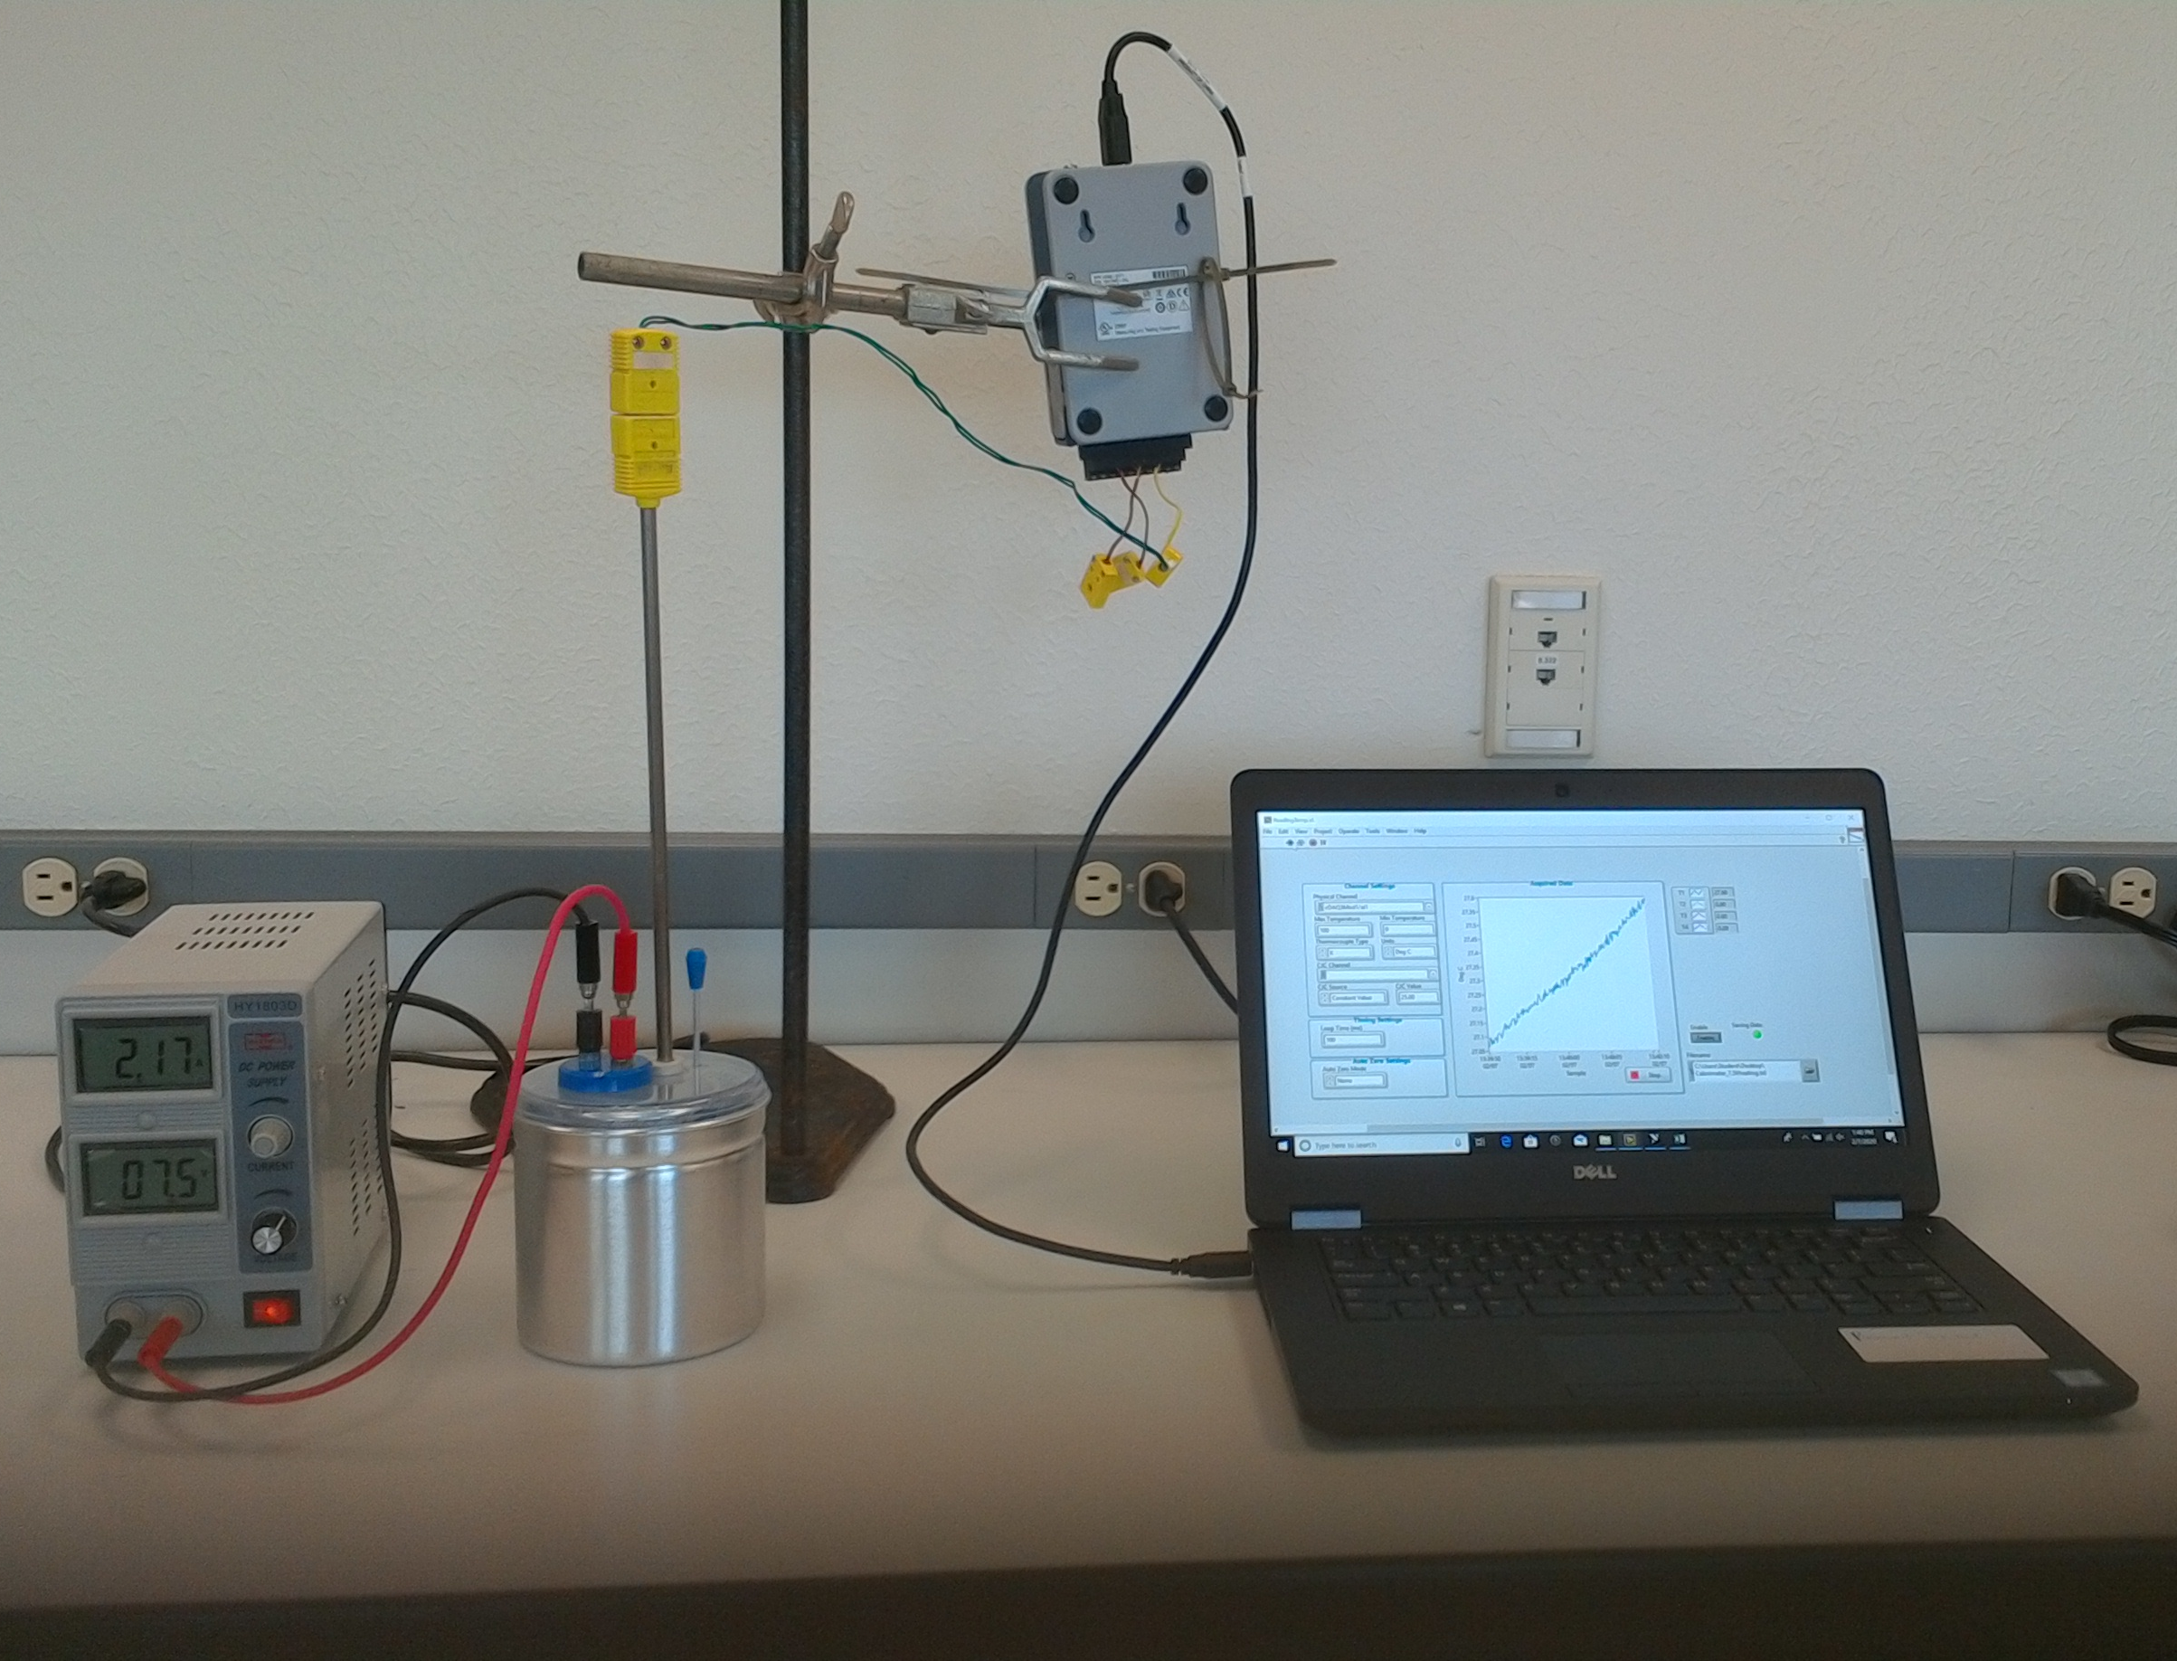
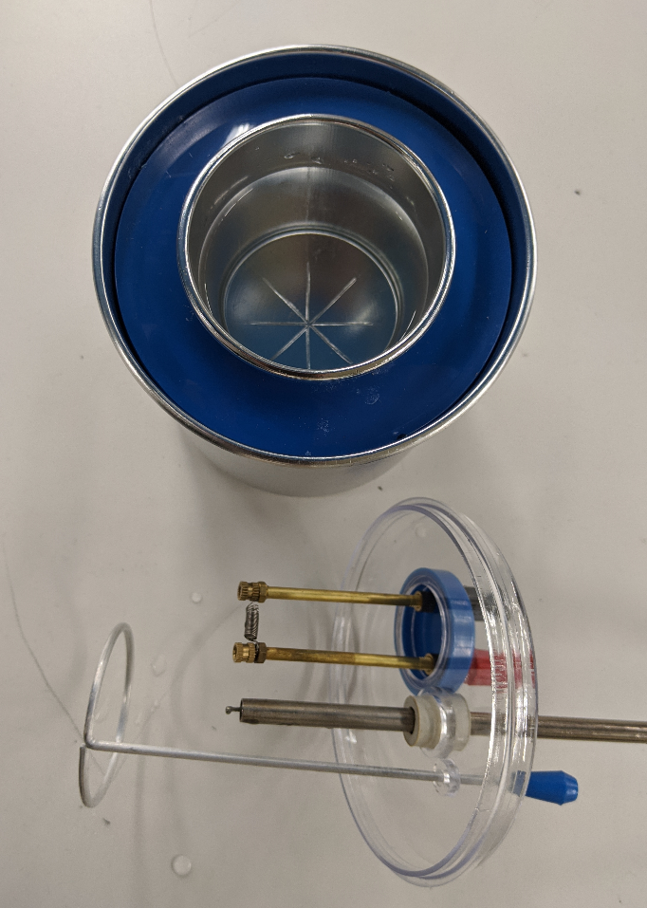
Thermocouple
Stirrer
Heating coil
Insulation
Sample container

Procedures

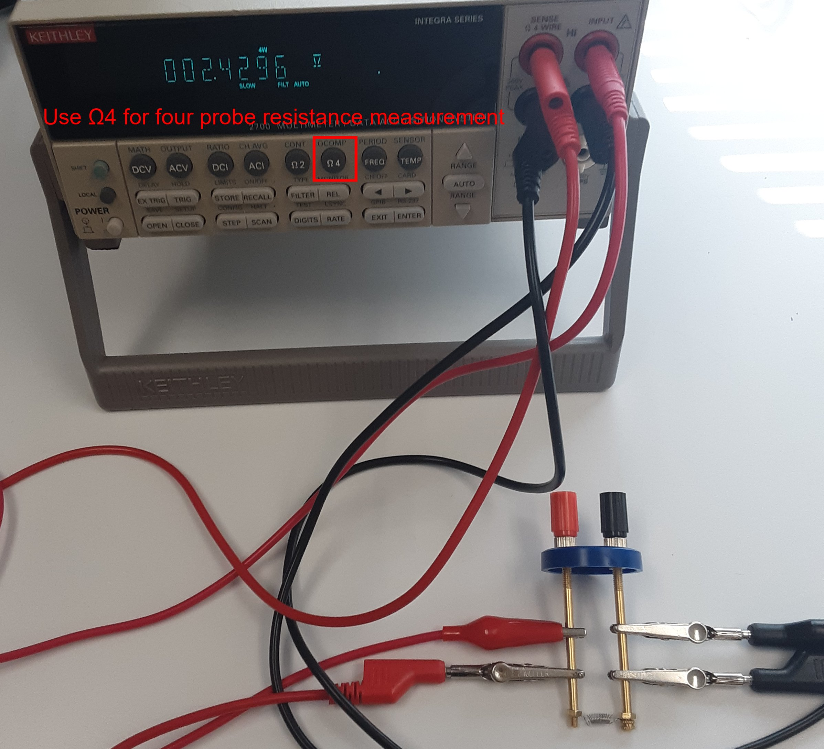
  - Use the Keithley to measure the four-wire resistance of the heating coil to eliminate the lead wire error. Connect two red wires between the red terminal of the heating coil and the two red terminals of the Keithley. Connect two black wires between the black terminal of the heating coil and the two black terminals of the Keithley. Press the Ω4 button on the Keithley to measure the four-wire resistance of the heating coil. The current flows in only one of the two red wires and one of the two black wires. The other red wire and black wire without a current flow are used to measure the voltage drop across the coil without including the voltage drop across the current-carrying red and black wires. As such, the electrical resistance obtained as the ratio between the voltage drop and the current does not include the black and red lead wire resistances.
  - Power on the laptop. The TA will provide the login and the password.
  - Connect the thermocouple to the NI USB-9211 and ensure that the USB cable from the NI USB-9211 to the laptop is connected.
  - Prepare room temperature water by measuring out 150 milliliters of water from the sink.
  - Open the Labview data acquisition program ReadingTemp.vi on the desktop. First click on the button of “Physical Channel” and select “Dev/ai0”. At the right side corner, click the button of a folder and create a new txt file at the directory and select it
  - Begin acquiring data using ReadingTemp.vi by pressing “run ”. The data file is a tab-delimited, text file and will be used for the calculation of the heat capacitance of water (part of the lab report). Ask your TA if you have any problems with Labview. Note that you can change the display interval in Labview. You should NOT attempt to modify the ReadingTemp.vi script.
  - Insert the Type K exposed thermocouple through rubber cork and into the water and let it come to equilibrium with the water.
  - Immerse the heating coil in the water bath (about 1.5 inches deep) and tighten into the slot on the lid. Once the heater is fully immersed, TURN ON the heater by turning on the DC power source. Record the voltage and current you are using. You will know the heater is on if small bubbles start to develop on the coil surface after about 15-30 seconds.
  - Record the measured water temperature for about 10 minutes.
  - Turn off the immersion heater by turning off the DC power source. LEAVE THE HEATER IN THE WATER TO COOL OFF.
  - Stop the data acquisition. Transfer your files onto a memory stick or email them to yourself. You will use them for the lab 3 report. Important Note: Make sure you take your files with you! Your data will not be recoverable after you leave this lab
  - Close Labview. Make sure to transfer your data from the laptop onto your portable memory device

Congratulations! You have completed lab 2.

